My Values

Jennifer Vermet

1. **Excitement**

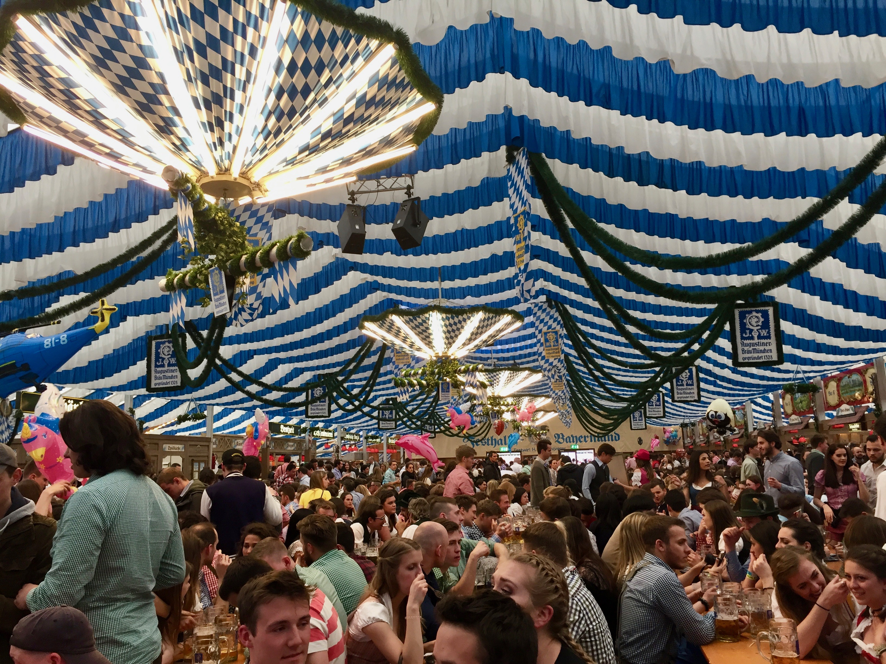

Spring Fest in Munich, Germany was such an exciting event. I got t o meet people from across the world that all were dressed in funky outfits and shared my value of having fun while drinking beer, dancing and eating pretzels.

1. **Curiosity**

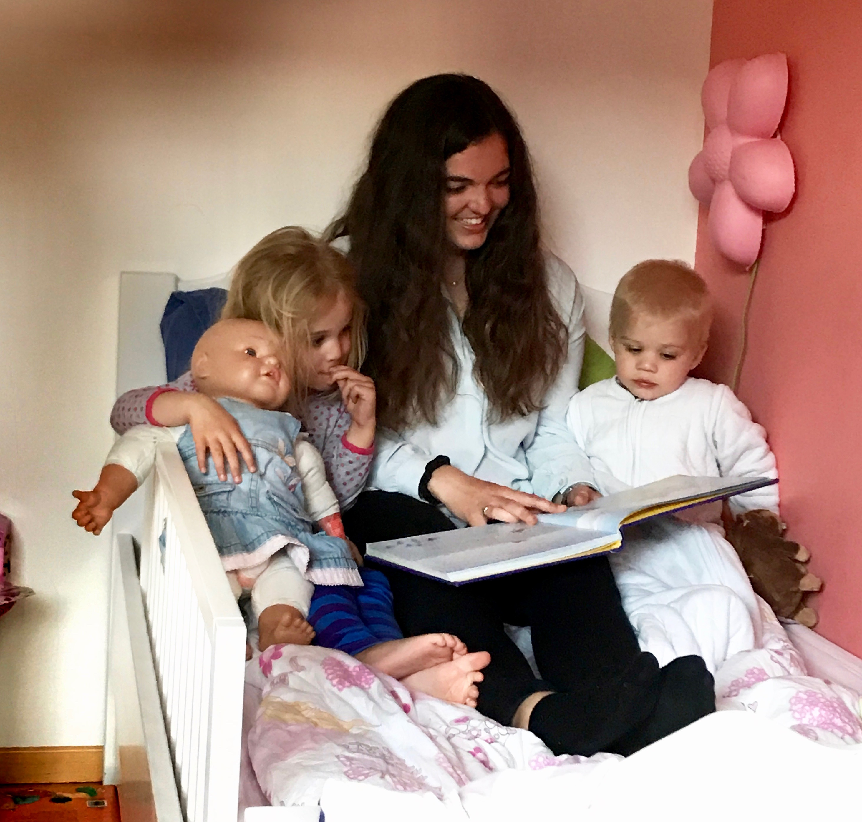

I was curious about how hard it would be for me to read this Dutch story to my Dutch cousins who don’t know any English before bed. They laughed at every word I spoke because I had no idea what I was saying. I was curious and could tell from the pictures, but I was a curious moron.

1. **Honesty**

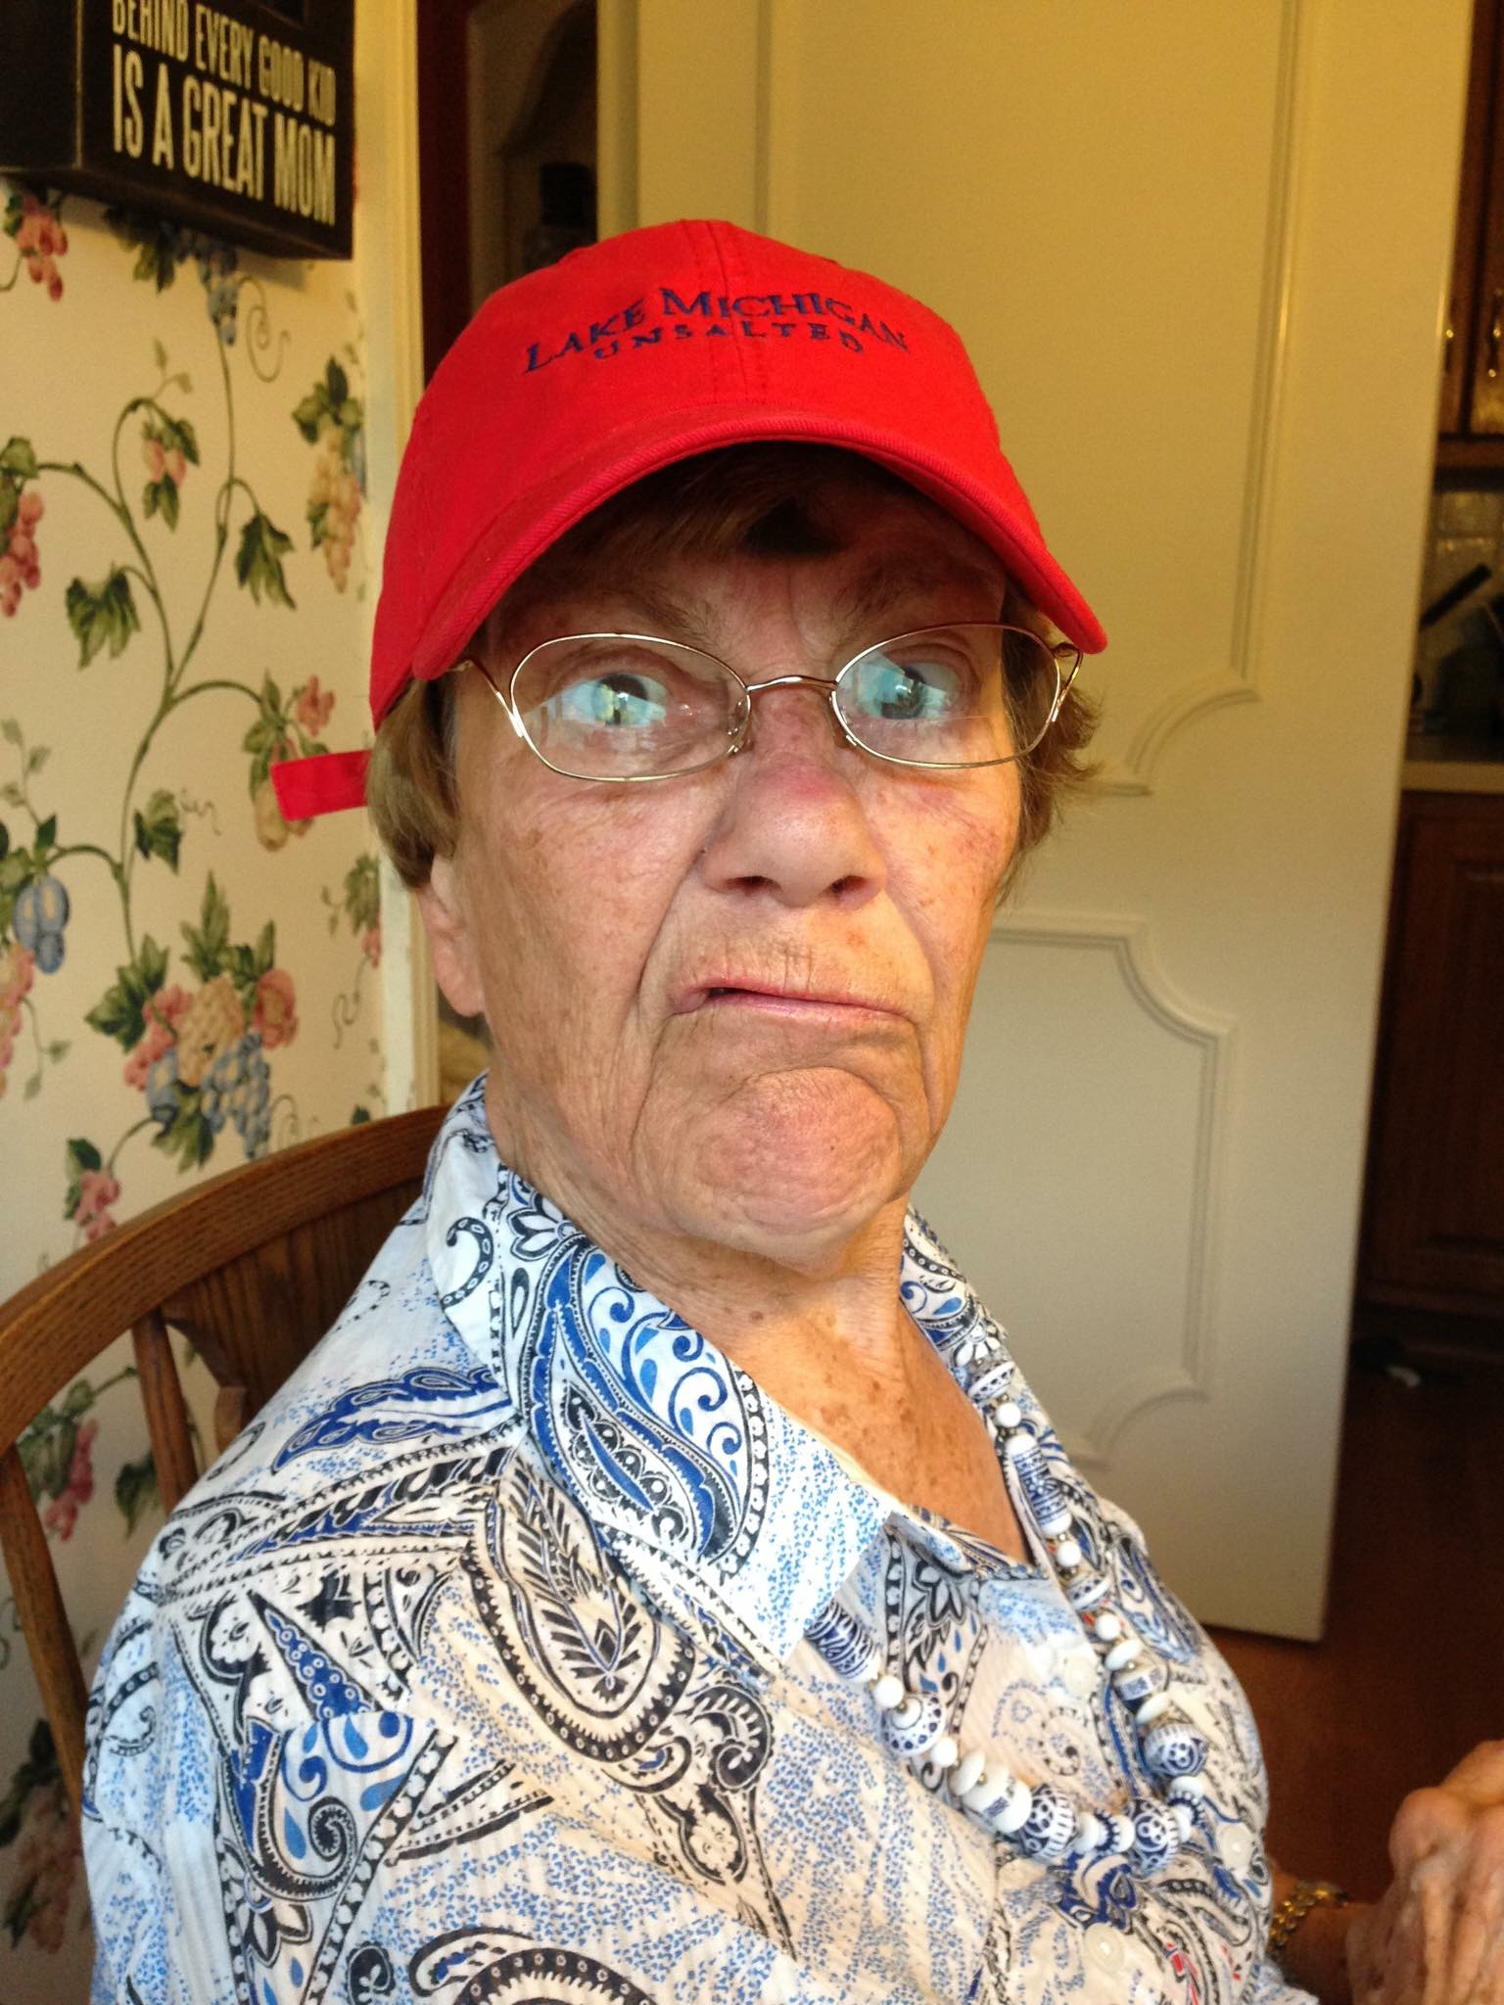

Here is a picture of the most honest woman I know. She is my grandmother. She is very direct in nature from her home culture of the Netherlands. It has only gotten more severe with her Alzheimer’s and comes off as very mean and rude to others. I respect her though because she is never manipulative or lies to me.

1. **Relationships**

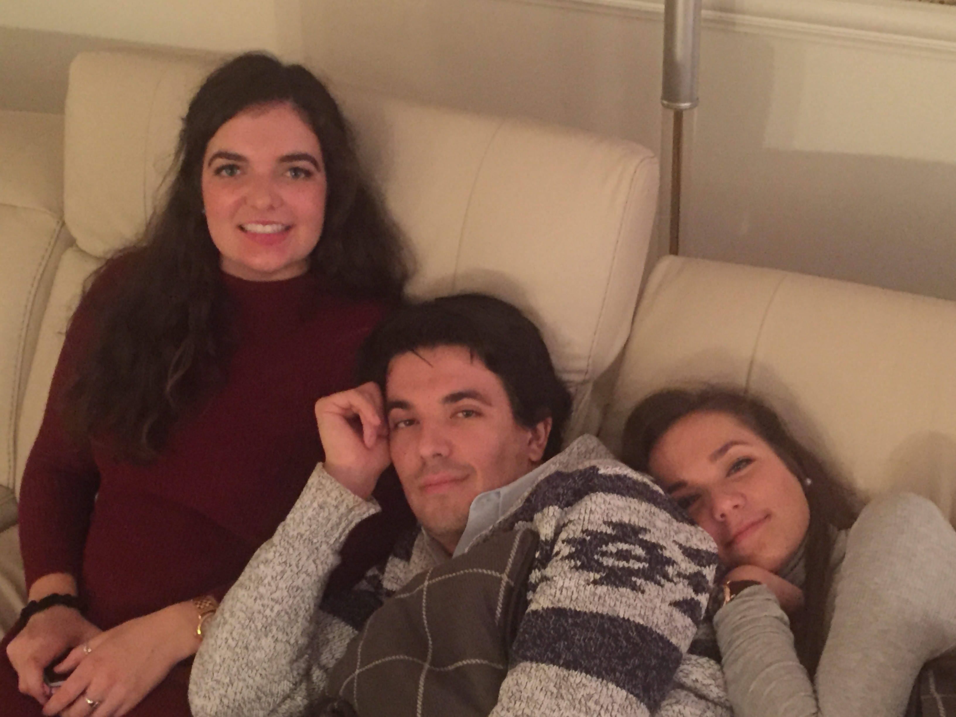

This is my brother and sister. Mitch and Stephanie are very important in my life because they are usually some of the first to know my inner thoughts and will give me an honest reaction.

1. **Humor**

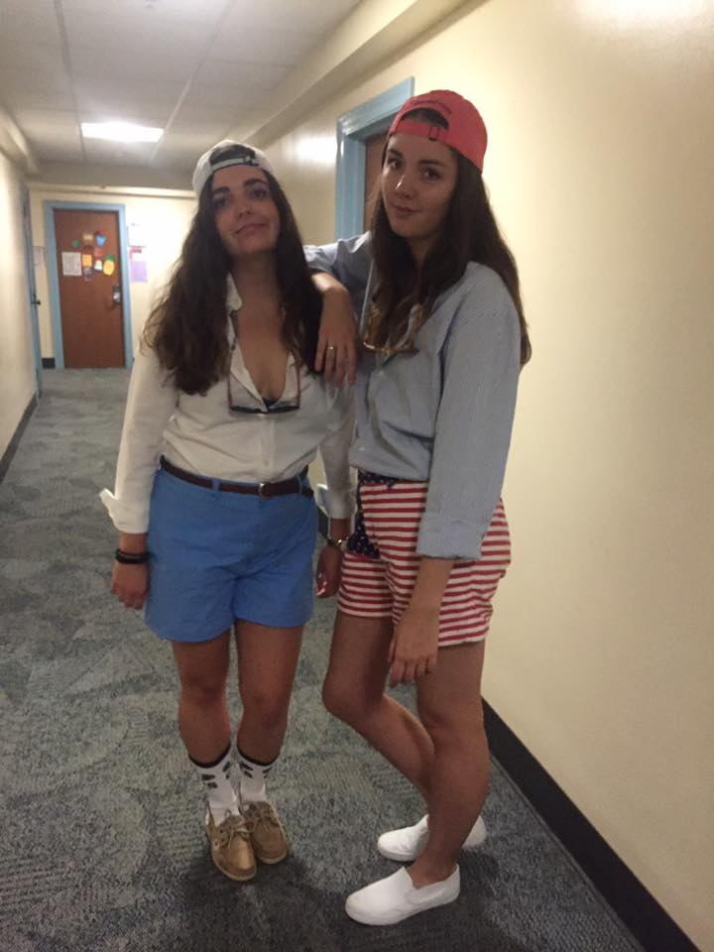

I dressed up as a fraternity boy for Halloween. I thought this was quite humorous as my little and I are sorority girls.

1. **Spontaneity**

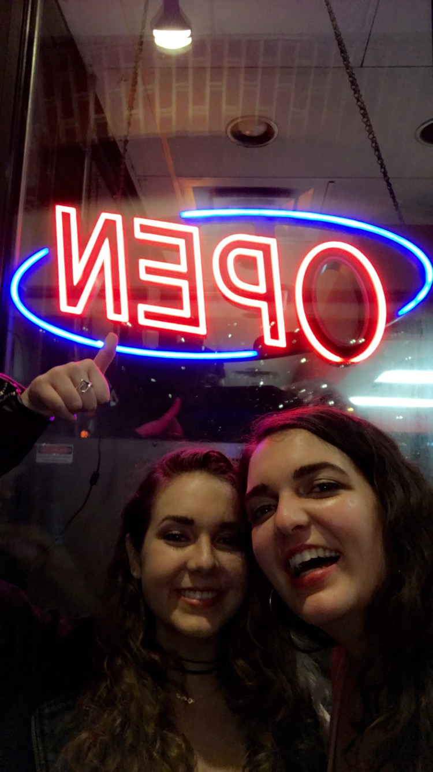

Two weekends ago, I allowed my sister to visit me at school with two hours notice despite the bad rainy weather. She was feeling down as was I. I missed her face. This picture depicts us deciding to go tot get Skyline Chili at a late hour and being very excited that they were still open!