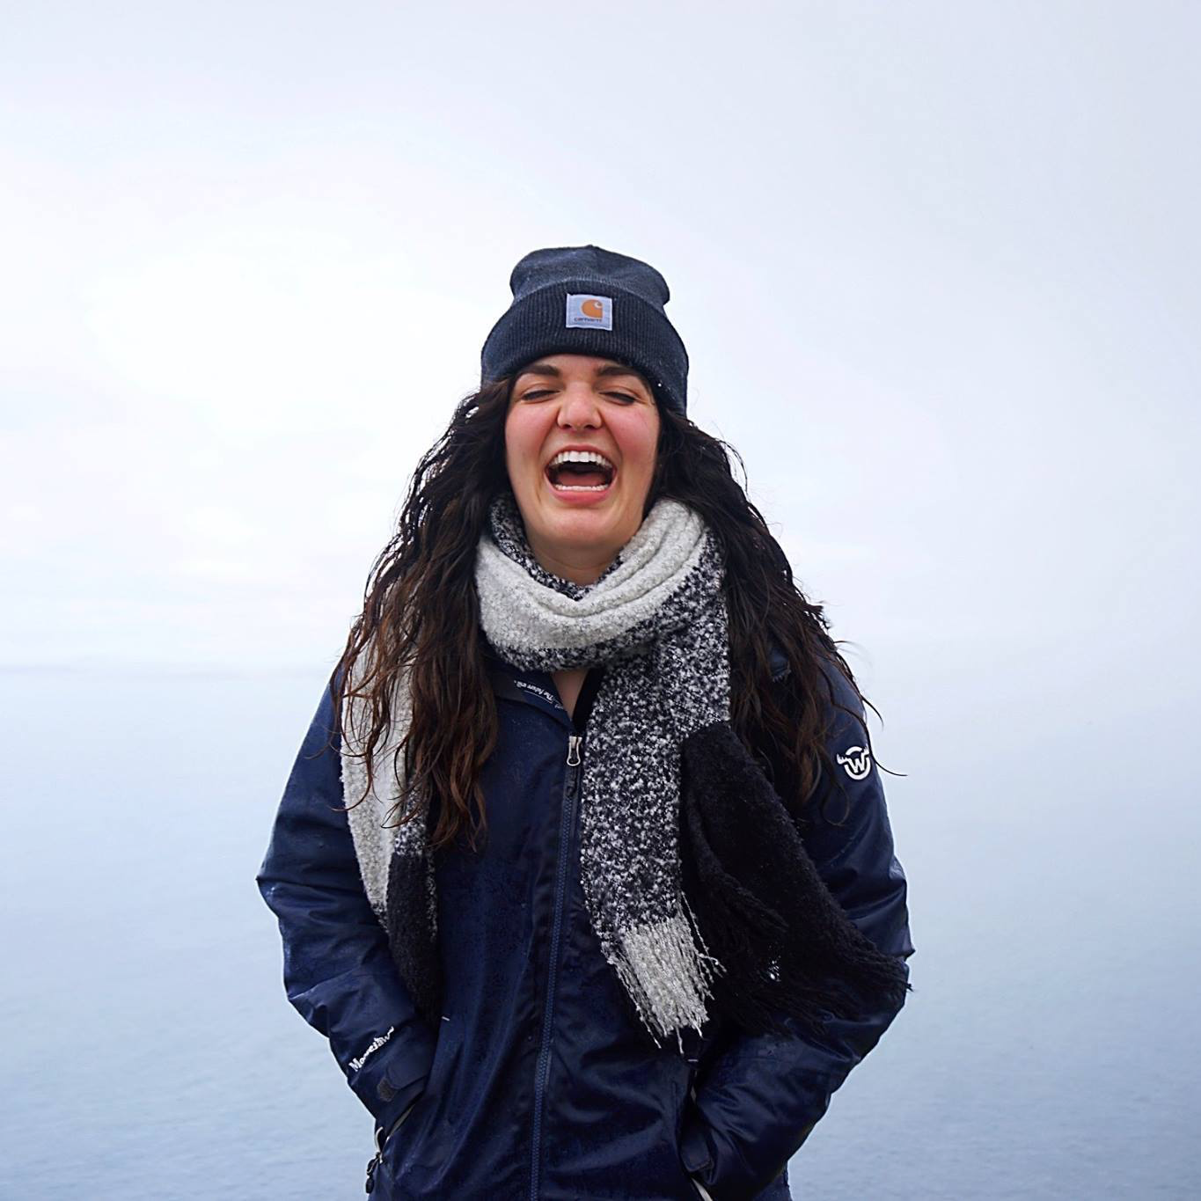

Saying Yes When My VOJ Says No

The possibility for new experiences and insights, the opportunity to fail, and challenging my VOJ are what fuels my creativity.

I studied abroad as a freshman during J-term in Luxembourg, my sophomore J-term in Fiji, and my spring semester junior year in Amsterdam. These experiences deliberately forced me out of my comfort zone near my panic mode, yet helped me to learn so much more about my creative mindsets than I would in my familiar environment of Oxford, Ohio. Traveling helped me to embrace ambiguity and think on my feet in absence of expectations and feel empathetic through becoming self aware while learning about others.

I liked knowing, as a foreigner, that I had so much to discover from those around me. I could easily silence my VOJ and approach locals around me. More specifically, I engaged with strangers every day while at red lights on my bike, on the metro, in every plane I boarded, in lecture halls with students, at football games, and in pubs. I knew I would never see them again, so I had nothing to lose. Traveling brings out the best in my ability to silence my VOJ, but I am constantly striving to find that strength in my everyday life. It is a persistent battle to suppress my judgmental thoughts from overcoming my creative journey through taking risks.

Jennifer Vermet
Senior
Finance Major
Grosse Pointe, Michigan
Fun Fact: I am trying to learn more Dutch for when I attend my cousin’s wedding on June 15th in the Netherlands!

